1. What command would you give in order to display the following information?
C 192.168.2.0/24 is directly connected, Ethernet0/0
C 192.168.5.0/24 is directly connected, Serial0/0
R 192.168.3.0/24 [120/1] via 192.168.5.1, 00:00:03, Serial0/0
R 192.168.6.0/24 [120/2] via 192.168.5.1, 00:00:03, Serial 0/0
- RouterA# show ip route
- RouterA# show ip interfaces
- RouterA# show routing table
- RouterA# show RIP routing

2. Which statements are true about the information in the following display? (Choose 3)
C 192.168.2.0/24 is directly connected, Ethernet0/0
C 192.168.5.0/24 is directly connected, Serial0/0
R 192.168.3.0/24 [120/1] via 192.168.5.1, 00:00:03, Serial0/0
R 192.168.6.0/24 [120/2] via 192.168.5.1, 00:00:03, Serial 0/0
- Two routing protocols are being used
- RIP is being used
- Routes to two networks have been discovered using RIP
- Routes to four networks have been discovered using RIP
- The route to 192.168.6.0 involves 120 hops
- The route to 192.168.6.0 involves 24 hops
- The route to 192.168.6.0 involves 2 hops

3. A routing table shows the following.
C 192.168.2.0/24 is directly connected, Ethernet0/0
C 192.168.5.0/24 is directly connected, Serial0/0
R 192.168.3.0/24 [120/1] via 192.168.5.1, 00:00:03, Serial0/0
R 192.168.6.0/24 [120/2] via 192.168.5.1, 00:00:03, Serial 0/0
Which of the following IP addresses could be addresses of interfaces on this router? (Choose 3)
- 192.168.2.1
- 192.168.2.2
- 192.168.3.1
- 192.168.3.2
- 192.168.5.1
- 192.168.5.2
- 192.168.6.1
- 192.168.6.2

4. A routing table shows the following.
C 192.168.2.0/24 is directly connected, Ethernet0/0
C 192.168.5.0/24 is directly connected, Serial0/0
R 192.168.3.0/24 [120/1] via 192.168.5.1, 00:00:03, Serial0/0
R 192.168.6.0/24 [120/2] via 192.168.5.1, 00:00:03, Serial 0/0
How did the route to 192.168.5.0 get into the routing table?
- It was configured as a static route by an administrator.
- It was learned using the RIP routing protocol.
- An address on the network was configured on Ethernet port 0/0.
- An address on the network was configured on Serial port 0/0.

5. What type of routing protocol is RIP? (Choose 2)
- Internal
- External
- Border
- Distance vector
- Link state

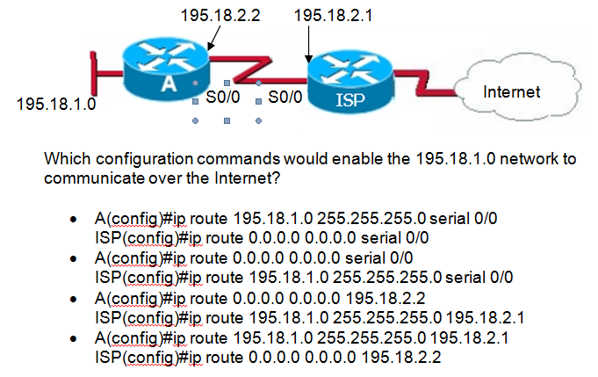
6.
7.
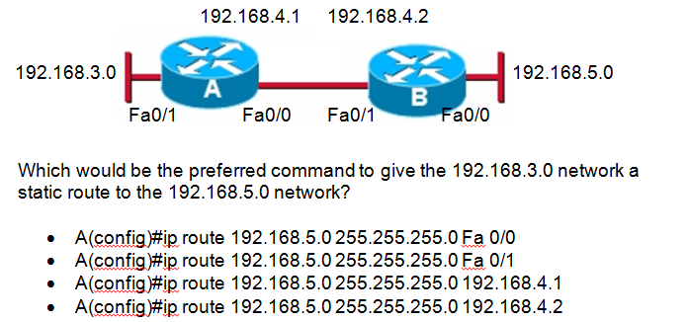

8. Which address would best summarize networks 172.30.0.0/24 and 172.30.1.0/24?
- 172.30.0.0/22
- 172.30.0.0/23
- 172.30.0.0/24
- 172.30.0.0/25

9. Which address would best summarize networks 172.30.4.0/24, 172.30.5.0/24, 172.30.6.0/24 and 172.30.7.0/24?
- 172.30.0.0/22
- 172.30.0.0/23
- 172.30.4.0/22
- 172.30.4.0/23

10. Which address would best summarize networks 192.168.3.0/28, 192.168.3.16/28, 192.168.3.32/28 and 192.168.3.48/28?
- 192.168.3.0/26
- 192.168.3.0/27
- 192.168.3.0/28
- 192.168.3.0/29

